**The Economic Account of Carter Grant**

My name is Carter Grant, and I grew up in Kaysville, Utah in a comfortable suburb with a strong middle-class presence. I chose to write my economic account about myself because I want to better understand where my income goes and how the choices I’ve made reflect broader economic principles. I’ve always considered myself a relatively good saver and budgeter, and one point of pride is that I will be graduating with my bachelor’s degree without any student debt. As I reflect on my work, spending, and financial decisions, I’ve realized that many aspects of my life are shaped by both microeconomic forces like opportunity cost and demand, and macroeconomic conditions, including inflation and the labor market.

I grew up in a financially stable household. My family lived in a middle-class neighborhood where most families were in similar economic circumstances. I never felt we lacked what we needed, but we weren’t extravagant either. I received financial support for college in the form of a scholarship, which has helped me avoid loans and stay financially independent. That scholarship, which was rewarded based on academic performance, is a great example of how incentives affect behavior, which is a key microeconomic concept. In this case, the incentive of reduced tuition pushed me to study hard and achieve good grades in high school.

My current consumption patterns are shaped by both personal preferences and budget constraints. I spend money on groceries, gas, clothes, restaurants, and fun activities with friends. I also pay for small subscriptions like ChatGPT and contribute to an IRA. I’ve made deliberate trade-offs in my spending based on income limits. For example, I used to get tattoos regularly, but now I’ve stopped because my budget doesn’t allow for that kind of discretionary spending. This is a clear case of opportunity cost, by choosing to save or spend elsewhere, I sacrifice one option for another. When grocery shopping at WinCo, I often buy the store brand instead of name brands, reflecting price elasticity of demand. My preferences change when prices do. On the other hand, some spending like gas, rent, or my school-related expenses are more inelastic, since I can’t easily reduce or substitute them. Below is a graph estimating my monthly expenses during the school year I created using python. This can vary depending on the month but this is a good spread of what my spending includes.

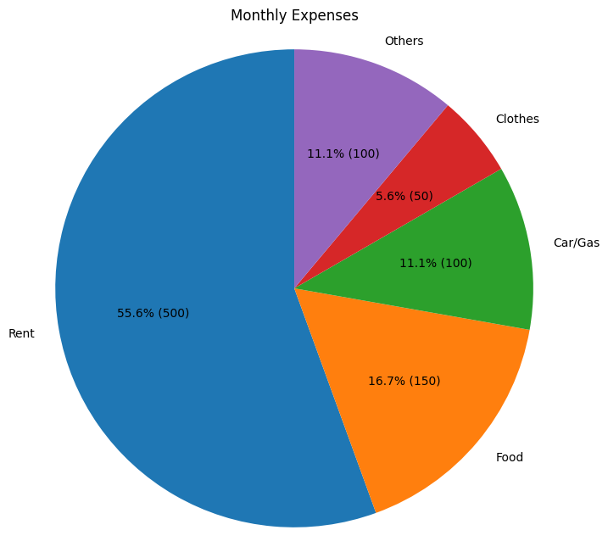Fig 1 (in USD)

The types of markets I interact with as a consumer are mostly competitive. Grocery stores, clothing outlets, and gas stations all operate in markets where multiple firms sell similar products, keeping prices relatively stable. As a laborer, however, I’ve experienced a more limited job market, especially in Logan, Utah, where I currently live. Utah State University, where I study and work, is the largest employer in Cache County. This gives them monopsony-like power in the labor market, where they can influence wages due to limited competition for student workers. Below is another graph I created in python showing the top 10 employers in cache county. Utah State dwarfs them all, and luckily, they are fair in their pay and student oriented.

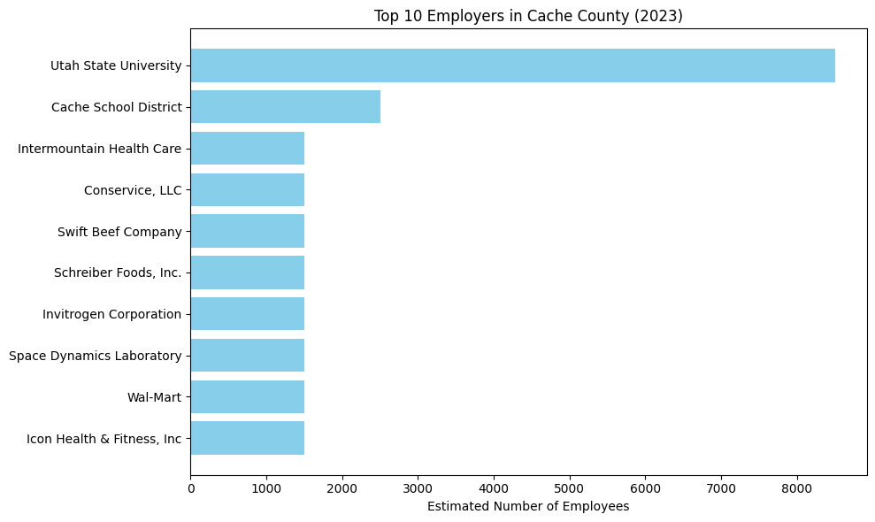(fig 2)

Over the years, I’ve had several jobs, each offering a different view of how labor markets function. In high school, I worked at Krispy Kreme for three years as a doughnut maker. Later, I delivered DoorDash, and I spent two summers building freeze dryers in a warehouse. During college, I’ve worked for Utah State University as a teaching assistant, in facilities, and for the Analytics Solutions Center. These roles were all part-time during the school year, roughly 20 hours per week. How I found these jobs also reflect different labor market strategies. For instance, some came through networking and connections (such as the warehouse job through a friend’s grandfather), while others were found through platforms like Handshake or by talking directly with professors. These job searches reflect the importance of human capital and labor market access.

Pursuing a degree in data analytics is my personal investment in human capital. I enjoy using numbers to solve problems, and I see this field as one where analytical thinking and technical skills meet real-world applications. Specializing in data analytics increases my productivity and potential income over time, but it also comes with trade-offs. Right now, I’m taking 19 credits and working 20 hours a week, which is demanding. I’m constantly weighing trade-offs between time for school, work, relationships, and rest. These choices are directly tied into opportunity cost and resource allocation, which are all fundamental ideas in microeconomics.

My annual income is roughly $17,000, and I estimate that I spend about $16,000 and save around $1,000 each year. Most of my expenses go to groceries, rent, and car-related costs. I don’t follow a written budget, but I keep a mental one that helps me avoid overspending. I give myself limits for different categories and adjust as needed. This informal budgeting approach still reflects economic rationality: I aim to maximize my utility given limited resources. The composition of my budget shows how I prioritize necessities while also allocating some income for enjoyment and future security.

The broader economy also affects me in more ways than I realized before this project. Inflation has recently noticeably increased the cost of groceries and gas, which reduced my real income and forcing me to cut back in other areas. I also experienced the effects of COVID-19, which disrupted the job market and made internships harder to find. Right now, Logan’s job market for tech and data roles is sluggish, limiting opportunities unless I relocate. Still, working for Utah State has provided stable employment, showing how large institutions can act as economic anchors in local markets. These experiences demonstrate how macroeconomic conditions like inflation, economic shocks, and job growth can shape individual opportunity.

Looking forward, I hope to work in sports analytics for the NBA or go into international business with a focus on China. I’ve been building toward this by earning my degree, studying Data Analytics and Chinese, networking with professors, and taking specialized courses. These are all long-term investments in my future income potential. My main financial goal is to live beyond paycheck-to-paycheck and build enough savings to handle emergencies and invest. However, I’m also realistic about the challenges ahead. Inflation, potential recession, and rising housing prices are all structural issues that could affect my career and lifestyle. Understanding these risks allows me to plan proactively.

Writing this paper helped me realize that I’m already applying economic principles every day. I face trade-offs in how I spend my time and money. I respond to incentives, deal with price changes, and invest in my own human capital. I navigate both competitive and concentrated markets as a consumer and worker. And like everyone, I’m influenced by larger economic conditions that I can’t control but must adapt to. By thinking through my personal economy in this way, I’ve gained a deeper understanding of how economics is not just something I study, but something I live.

**Works Cited**

* Bureau of Labor Statistics (BLS). [https://www.bls.gov](https://www.bls.gov/)
* Department of Workforce services: (fig 2) <https://jobs.utah.gov/wi/data/library/firm/majoremployers.html>
* Personal reflections and employment records by Carter Grant (fig 1)